EXPT NO:5 | DEVELOP INTERACTIVE DASHBOARDS FOR DYNAMIC DATA EXPLORATION USING TABLEAU AND POWERBI
DATE: 24.07.2026

PRE-LAB QUESTIONS

1. What is dynamic data exploration in BI tools, and why is it important?
Dynamic data exploration allows users to interact with data in real time — filtering, drilling down, and changing views without altering the underlying dataset. It is important because it enables self-service analytics and helps users uncover insights specific to their needs.

2. What are slicers and filters, and how do they enhance dashboard interactivity?
Slicers and filters are visual controls that let users narrow down displayed data based on selected criteria (e.g., date, region, category). They enhance interactivity by allowing users to dynamically update all connected visuals to focus on relevant data.

3. How do Tableau and Power BI support drill-down and drill-through features?
Tableau supports drill-down through hierarchies (e.g., Year → Quarter → Month) directly on visualizations. Power BI supports drill-down similarly, plus drill-through pages that let users right-click a data point to jump to a detailed report filtered for that context.

4. What is the role of parameters in creating interactive dashboards?
Parameters allow users to dynamically change values that affect calculations or visualizations, such as switching between metrics (Sales vs. Profit) or adjusting thresholds, without editing the underlying data or formulas.

5. Name some advanced interactivity features in Tableau and Power BI.
Advanced features include highlight actions, dashboard actions (filter/URL actions), bookmarks, tooltips with embedded visuals, set actions, what-if parameters, and drill-through pages.

IN-LAB EXERCISE:
OBJECTIVE:
To design and develop interactive dashboards in Tableau and Power BI for dynamic data exploration, enabling users to analyze, filter, and drill down into data for deeper insights.
PROCEDURE:
- Data Collection:
    - Import datasets from sources such as Excel, CSV, SQL Server, or online APIs.
    - Dataset: Retail Sales Dataset with fields such as Order Date, Region, Product Category, Sales, Profit, Quantity.
- Data Preparation and Transformation:
    - Ensure proper date formats for time-based analysis. o Handle missing or incorrect values.
    - Create calculated fields (e.g., Profit Margin %, Sales Growth %, Year-to-Date Sales).
- Data Aggregation and Hierarchies:
    - Create hierarchies (e.g., Year → Quarter → Month → Day).
    - Aggregate data by region, product category, or customer segment.
- Designing Interactive Elements:
    - Filters & Slicers: Allow filtering by product category, date range, or region. o Parameters: Let users switch between KPIs (e.g., Sales vs. Profit). o Drill-down: Enable users to explore data from summary to detail.
    - Tooltips: Add contextual details when hovering over data points.
- Dashboard Development:
    - Tableau: Use interactive filters, parameter controls, and highlight actions.
    - Power BI: Use slicers, bookmarks, and drill-through pages.
    - Add KPI cards for key metrics like Total Sales, Total Profit, Top Selling Product. o Use maps for regional sales analysis, line charts for trends, and bar charts for category comparisons.
- Testing Interactivity:
    - Ensure slicers and filters update all relevant visuals dynamically.
    - Test drill-down and drill-through functionality for accuracy.
- Publishing and Sharing:
    - Tableau: Publish on Tableau Public or Tableau Server.
    - Power BI: Publish to Power BI Service and share via workspace access or public link.
Experiment Dataset:
Retail Sales Dataset
Fields Used:
  - Order Date – Date of the order
  - Region – Sales region
  - Product Category – Category of product sold
  - Sales – Sales revenue
  - Profit – Net profit from the order
  - Quantity – Units sold
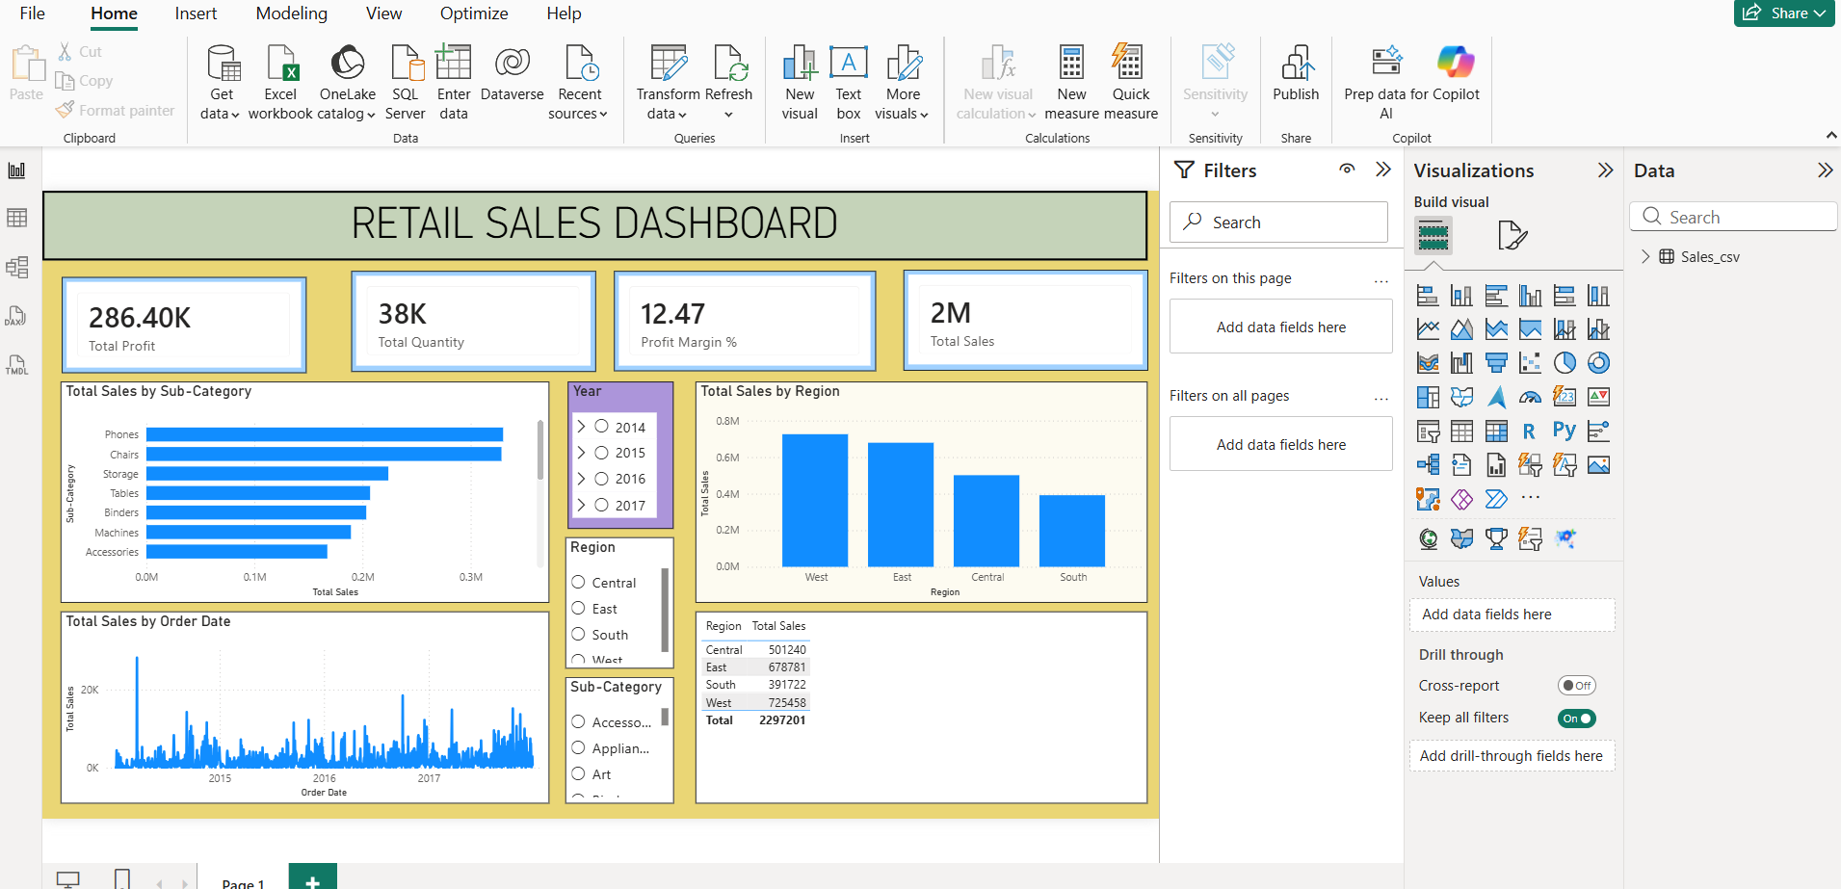
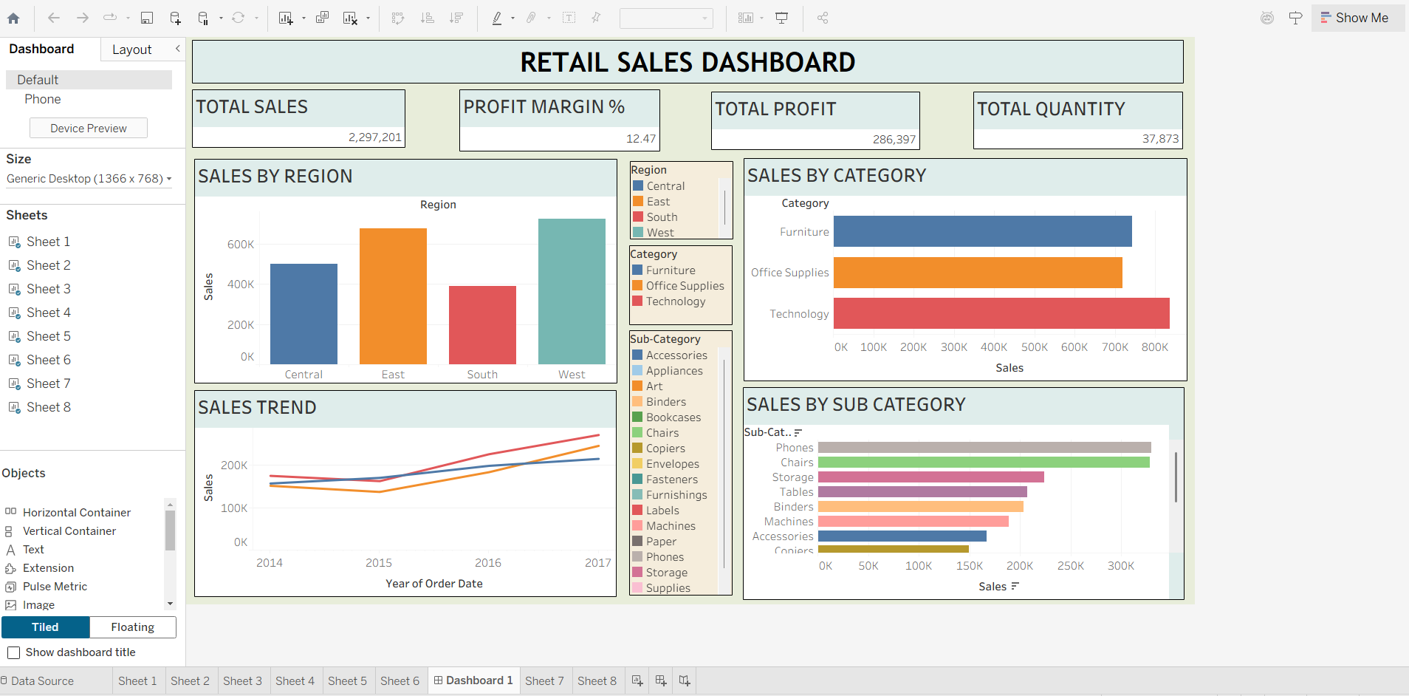

POST-LAB QUESTIONS

1. How did interactivity improve the analysis experience in your dashboard?
Interactivity allowed users to explore sales and profit data from multiple angles (region, category, time) without needing separate static reports, making analysis faster and more intuitive.

2. Which interactive feature (filters, drill-down, parameters, etc.) was most useful and why?
Drill-down was most useful as it allowed users to move from a high-level yearly view down to daily details, helping identify specific periods driving sales trends.

3. What challenges did you face while implementing drill-down or dynamic filters?
Challenges included ensuring hierarchies were correctly structured and that all visuals updated consistently when filters were applied, especially when multiple data sources were involved.

4. How do tooltips contribute to better dashboard storytelling?
Tooltips provide contextual, on-demand details without cluttering the main visualization, helping users understand specific data points and supporting a cleaner, more focused narrative.

5. What additional features would you add to make the dashboard more insightful?
Adding forecasting, trend lines, comparative benchmarks, and natural language Q&A features would make the dashboard more insightful and user-friendly.

RESULT:

The retail sales dataset was successfully transformed, aggregated, and visualized into interactive dashboards in Tableau and Power BI. Filters, slicers, drill-downs, and parameters enabled dynamic exploration of sales and profit trends by region, product category, and time period. The resulting dashboards allowed for quick insights and deeper analysis, enhancing decision-making capabilities.

ASSESSMENT

Description |  | Max Marks | Marks Awarded
Pre Lab Exercise |  | 5
In Lab Exercise |  | 10
Post Lab Exercise |  | 5
Viva |  | 10
 | Total | 30
 | Faculty Signature

